Team09.Presonalized invitation using

Projet Document

20 unlque way to personalize your wedding invitation

1.design a monogram

2. seal it with wex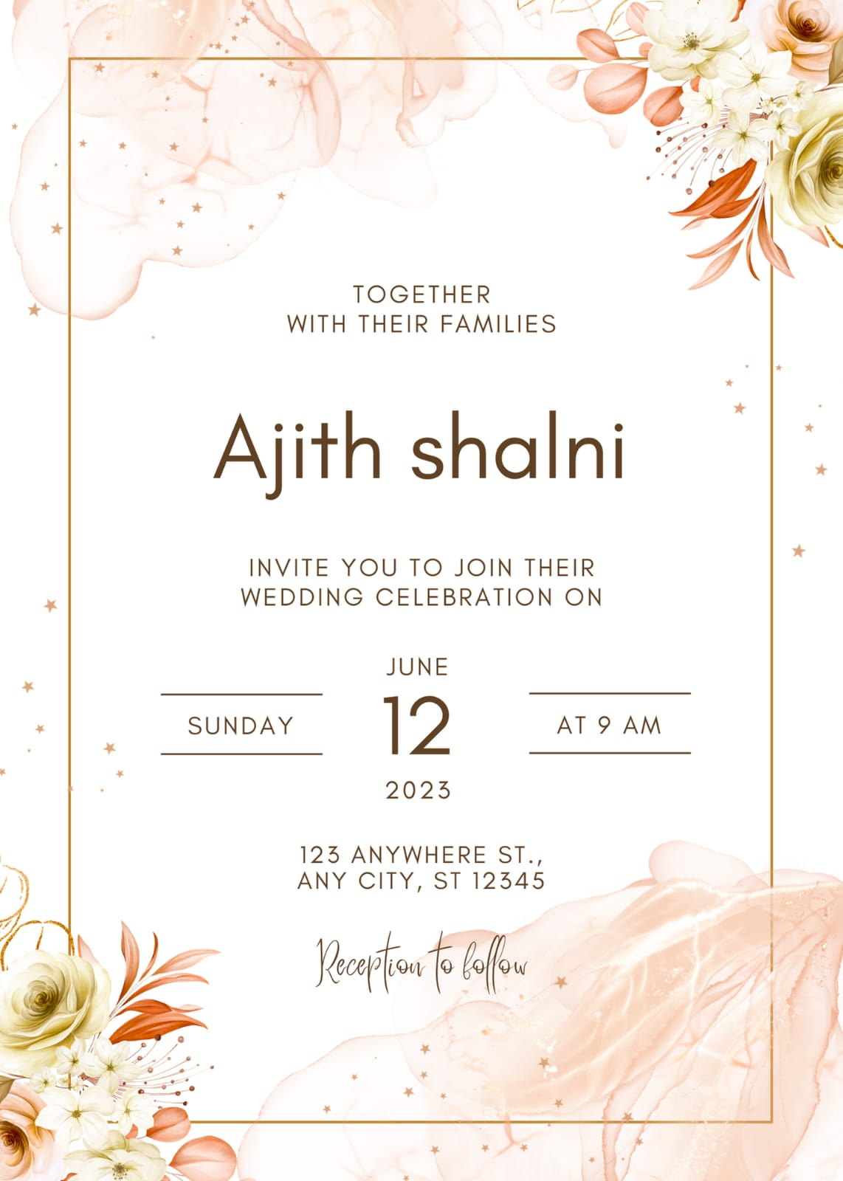

What is the best paperless invitations?

.Evite and punchbowl

How to make AI-generated images

Start a design project from scratch or with a template. ...

Describe the image you'd like to generate. ...

If using Magic Media's Text to Image, you can also choose an image style from our available options like Watercolor, Filmic, Neon, Color Pencil, and Retrowave.

What software is used for invitation cards?

Adobe Express makes invitation design easy.

This free invitation maker allows you to express the spirit of your event. Whether it's a low-key house party or the wedding of the century, a tailored, custom-made invitation

Should wedding invitations be personalized?

Benefits of Custom Wedding Invitations

Makes your guests feel special- Obviously, your event is a “special occasion.” Sending a customized paper invitation shows that you put in the effort and even spent money to make sure you included them in your event. It also shows how much planning you have put into your event.

Can I use Canva for wedding invitations?

Making your own wedding invitations in Canva is intuitive and easy. So easy, in fact, that once you've created one item of stationery, it's just a matter of a few clicks to create a whole suite of cohesive and unique stationery to perfectly reflect your wedding vibe.

What are the benefits of custom invitations?

Makes your guests feel special- Obviously, your event is a “special occasion.” Sending a customized paper invitation shows that you put in the effort and even spent money to make sure you included them in your event. It also shows how much planning you have put into your event

What is the rule for wedding invitations?

In order to make sure your guests can make the proper accommodations, plan on sending out your wedding invitations anywhere from 6-8 weeks prior to the wedding date. If, however, you are having a destination wedding, it is proper etiquette to send your wedding invitations out 12 weeks prior.